**Industrial Internship Report on**

**URL Shortener**

**Prepared by**

**Darren Immanuel Fernandes**

|  |
| --- |
| *Executive Summary* |
| This report provides details of the Industrial Internship provided by upskill Campus and The IoT Academy in collaboration with Industrial Partner UniConverge Technologies Pvt Ltd (UCT).  This internship was focused on a project/problem statement provided by UCT. We had to finish the project including the report in 6 weeks’ time.  The project I chose to undertake for the Python Internship offered upskill Campus was the URL Shortener, an application developed in Python that will allow users to shorten the links they input into it. The application will take long URLs and convert them into smaller and much more manageable links using an API. Apart from that, the overall scope of this project involved implementing a database to store the mapping between original and shortened URLs, and developing functions to generate unique shortened URLs and handle redirection.  This internship gave me a very good opportunity to get exposure to Industrial problems, and to design and then implement solutions for those. It was an overall great experience to have this internship. |

**TABLE OF CONTENTS**

1 Preface 3

2 Introduction 7

2.1 About UniConverge Technologies Pvt Ltd 7

i. UCT IoT Platform 7

2.2 About upskill Campus (USC) 10

2.3 About the IoT Academy 12

2.4 Objectives of this Internship program 12

2.5 Reference 12

2.6 Glossary 13

3 Problem Statement 14

4 Existing and Proposed solution 15

4.1 Code submission 17

4.2 Report submission 17

5 Proposed Design/ Model 18

5.1 High Level Diagram 18

5.2 Interfaces 19

6 Performance Test 21

6.1 Test Cases 21

6.2 Test Procedure 22

6.3 Performance Outcome 23

7 My learnings 24

8 Future work scope 25

# Preface

During the first week of the internship, I did some research on Python, its syntax and how it worked in comparison to the other programming languages I had worked with so far. I also analyzed all the options for projects we were given to choose from, and elected to work on creating a URL Shortener. Consequently, I kept the project’s primary goals and its problem statement in mind as I began to develop my chosen project.

In the second week, I decided to solidify the core functionality of my project, namely its URL Shortening functionality. After familiarizing myself with the *pyshorteners* library in python, I created a test program to see It functioned as intended, which it did. I also decided to primarily use the *customtkinter* library for creating the UI my project needed.

The third week was when I got to work on the appearance of my application, and the implementation of the URL Shortening feature in it. Much of the widgets that were used in *tkinter* and customtkinter are very similar to the ones used in Visual Basic, a language that I have some experience with. I learnt how to use simple widgets like *Labels*, *Entries* and *Buttons* and created a simple program using all three. With the knowledge I then had, I made a simple URL Shortener with a basic but adequate user interface that accepted inputs in the form of long URLs, and gave output in the form of shortened ones. Besides the URL Shortening function, I also created a function that validated the inputted links by checking if they replied with “200 OK” to a HEAD request. This was made possible by importing the *Requests* library.

In the fourth week, I addressed the project’s requirement of database functionality. Through the use of the *sqlite3* package, I was able to use some standard *SQL* commands in Python, which I tested out in a sample program. In the sample program, I inserted some information into a database in *SQLite*. The information was clearly viewable in the database using a tool called *DB Browser*. I was now able to successfully add this database functionality to the code I had developed the previous week, allowing for the storage as well as the mapping of shortened and original URLs in a locally embedded database.

I neared finalization of the coding aspect of my project in the fifth week and added some entries to my projects non-functional requirements, since I had satisfied all the functional requirements. I improved the application by adding more elements, and used a different method to more effectively place most of them. I also reworked the URL validation function I added earlier, enabling it to allow users to shorten more URLs than they previously could.

The sixth week is when I thoroughly reviewed all of my progress thus far. I conducted various tests to gauge the real-world performance of my application. I made minor changes to my code after extensive troubleshooting. This is also the week in which I will submit my final report detailing all of my work and progress so far, which brings me to where I am right now, as of the time I am writing this report.

Internships, such as the one offered by upskill Campus that I am undertaking, play a significant role in career development and can have various benefits for individuals seeking to build their professional paths. First and foremost, they provide an opportunity to gain hands-on experience in a specific field or industry. They will allow individuals to apply theoretical knowledge obtained from academic studies to real-world situations. Internships offer a chance to gain valuable insights into a particular industry or professional field. You can learn about industry practices, trends, and the day-to-day operations of the workplace. This knowledge can help you make informed decisions about your career path and develop a better understanding of the industry's expectations.

Internships allow you to explore different career paths and industries. They help you understand your interests, strengths, and weaknesses in a practical setting. This firsthand experience can help you make more informed decisions about your future career and prevent potential career changes down the road. Internships also provide excellent networking opportunities. Building relationships with professionals in your chosen field can lead to mentorship, future job opportunities, and references. Networking with colleagues, supervisors, and industry professionals can expand your professional network and open doors for future career growth.

Internships also help develop a wide range of skills, both technical and soft skills. Technical skills may include specific software proficiency, data analysis, project management, or laboratory techniques, depending on the field. Soft skills such as communication, teamwork, time management, and problem-solving are also honed through internships. In addition to the skill you’ve acquired, having internships on your resume demonstrates to potential employers that you have practical experience and are proactive in pursuing professional development. Internships showcase your ability to apply classroom knowledge to real-world scenarios and make you a more competitive candidate when applying for jobs.

The project I chose for my internship was the **URL Shortener**. The problem statement pertaining to my project describes a scenario in which one wishes to **shorten a URL** for the purpose of convenience, avoiding overcomplication of documentation, or simply adhering to character limits in certain social media platforms. The core features of my project are as follows:

* Dedicated functions to generate unique shortened URLs. These functions will also handle redirection.
* An aesthetically pleasing, modern and intuitive user interface.
* A database to store data relevant to the mapping of the original URLs to their shortened counterparts and vice versa.

Keeping with its original problem statement, however, the basic objective of my project will be to shorten URLs and convert them into smaller links that are easier to use. The shortened links can be implemented into memos, emails, announcements on social media and even other projects. These links will redirect users to the original link.

When I was required to take an internship by my college during my vacation, I was overjoyed to find a free internship offered by Upskill Campus in multiple interesting subjects like Core Java, App Development, Digital Marketing, etc. One course I was particularly interested in was Python since I had wanted to learn the language over my vacation.

Participating in this internship or collaboration program with Upskill Campus and utilizing this opportunity will provides a number of benefits. Upskill Campus and The IoT Academy, in partnership with UniConverge Technologies offers internship programs that focus on in-demand skills and technologies in the field of IoT (Internet of Things) and other areas of programming and application design. Interns are ensured that they acquire knowledge and skills that are directly applicable in the industry.

Collaborating with established companies like UniConverge Technologies provides interns with the opportunity to work with experienced professionals and subject matter experts in the field. Interns can learn from their expertise, receive guidance, and gain insights into industry best practices. This exposure can enhance their learning experience and help them develop a deeper understanding of the subject matter.

Having experience with recognized organizations such as the likes of UniConverge Technologies will make your resume stand out and demonstrate your ability to work in a professional setting. It also signifies that you have received training and exposure to industry-specific skills, making you a more attractive candidate to potential employers. Building connections with such industry experts and like-minded individuals, can and will open doors to future career opportunities, mentorship, and professional references.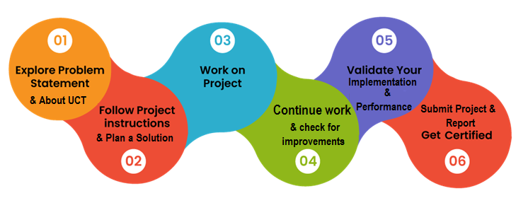

Over the course of this internship, I gained valuable insight into the real-world applications of Python in areas like Data Science and related topics like Search Engine Optimization and NumPy with its usage and significance. I also gained some very valuable experience in Python in a practical and hands-on approach since I had to develop a project myself using the language, a project that will be reviewed by professionals. I learnt how to implement a functional user interface into an application strictly using code, and not another GUI like in Visual Studio. I also learnt how to embed a functional database in that application. Finally, I got to create, develop and design that very application myself.

To that end I would like to thank Upskill Campus for providing me with the opportunity that made all this possible.

# Introduction

## About UniConverge Technologies Pvt Ltd

A company established in 2013 and working in Digital Transformation domain and providing Industrial solutions with prime focus on sustainability and RoI.

For developing its products and solutions it is leveraging various**Cutting Edge Technologies e.g. Internet of Things (IoT), Cyber Security, Cloud computing (AWS, Azure), Machine Learning, Communication Technologies (4G/5G/LoRaWAN), Java Full Stack, Python, Front end**etc.



1. UCT IoT Platform **(****)**

**UCT Insight** is an IOT platform designed for quick deployment of IOT applications on the same time providing valuable “insight” for your process/business. It has been built in Java for backend and ReactJS for Front end. It has support for MySQL and various NoSql Databases.

* It enables device connectivity via industry standard IoT protocols - MQTT, CoAP, HTTP, Modbus TCP, OPC UA
* It supports both cloud and on-premises deployments.

It has features to  
• Build Your own dashboard  
• Analytics and Reporting  
• Alert and Notification  
• Integration with third party application(Power BI, SAP, ERP)  
• Rule Engine



1. **Smart Factory Platform (****)**

Factory watch is a platform for smart factory needs.

It provides Users/ Factory

* with a scalable solution for their Production and asset monitoring
* OEE and predictive maintenance solution scaling up to digital twin for your assets.
* to unleased the true potential of the data that their machines are generating and helps to identify the KPIs and also improve them.
* A modular architecture that allows users to choose the service that they what to start and then can scale to more complex solutions as per their demands.

Its unique SaaS model helps users to save time, cost and money.



1. 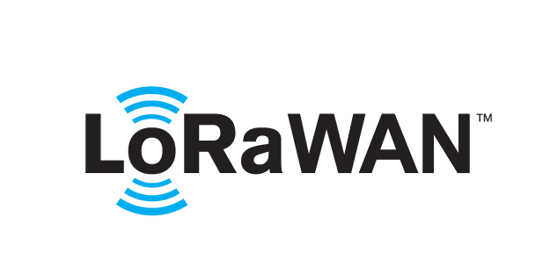 based Solution

UCT is one of the early adopters of LoRAWAN teschnology and providing solution in Agritech, Smart cities, Industrial Monitoring, Smart Street Light, Smart Water/ Gas/ Electricity metering solutions etc.

1. Predictive Maintenance

UCT is providing Industrial Machine health monitoring and Predictive maintenance solution leveraging Embedded system, Industrial IoT and Machine Learning Technologies by finding Remaining useful life time of various Machines used in production process.



## About upskill Campus (USC)

upskill Campus along with The IoT Academy and in association with Uniconverge technologies has facilitated the smooth execution of the complete internship process.

USC is a career development platform that delivers **personalized executive coaching** in a more affordable, scalable and measurable way.



Seeing need of upskilling in self paced manner along-with additional support services e.g. Internship, projects, interaction with Industry experts, Career growth Services

<https://www.upskillcampus.com/>

upSkill Campus aiming to upskill 1 million learners in next 5 year

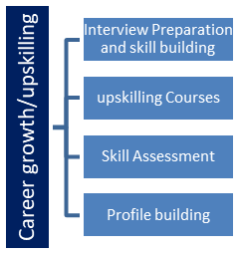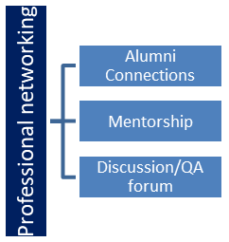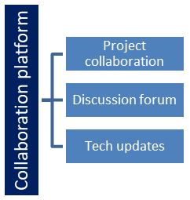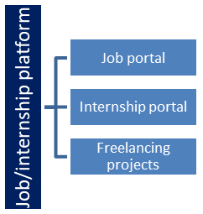

## About the IoT Academy

The IoT academy is EdTech Division of UCT that is running long executive certification programs in collaboration with EICT Academy, IITK, IITR and IITG in multiple domains.

## Objectives of this Internship program

The objective for this internship program was to

 ☛ get practical experience of working in the industry.

 ☛ to solve real world problems.

 ☛ to have improved job prospects.

 ☛ to have Improved understanding of our field and its applications.

 ☛ to have Personal growth like better communication and problem solving.

## Reference

* https://userguiding.com/blog/hr-software/
* https://www.trustradius.com/hr-management
* https://www.g2.com/categories/hr
* https://www.forbes.com/advisor/business/software/hris-systems/

## Glossary

|  |  |
| --- | --- |
| Terms | Acronym |
| URL | A URL (Uniform Resource Locator) is a unique identifier used to locate a resource on the Internet. It is also referred to as a web address. URLs consist of multiple parts -- including a protocol and domain name -- that tell a web browser how and where to retrieve a resource. |
| redirection | It refers to the process of forwarding a user from one web address (URL) to another. It is often used for various purposes, including website maintenance, content reorganization, and URL shortening. |
| PyShorteners | PyShorteners is a Python library that allows developers to integrate URL shortening functionality into their Python applications or scripts without having to deal with the complexities of interacting with each individual URL shortener's API. |
| API | An API, or an Application Programming Interface, is a set of rules and protocols that allows different software applications to communicate and interact with each other. It defines the methods and data formats that applications can use to request and exchange information. |
| Tkinter | Tkinter is and has been the standard Python library used to create graphical user interfaces (GUIs). It provides a set of tools and widgets to build windows, dialogs, buttons, menus, and other elements for desktop applications. |
| CustomTkinter | CustomTkinter is a python UI-library based on Tkinter, that provides new, modern and fully customizable widgets. |
| requests | The requests library is a popular Python module used for making HTTP requests. It provides a simple and user-friendly API for sending HTTP requests to web servers and handling their responses. |
| SQL | SQL is short for Structured Query Language. It is a programming language used to manage and manipulate relational databases. SQL allows users to create, retrieve, update, and delete data in databases. |
| SQLite | SQLite is a self-contained, lightweight, and embedded relational database management system. It implements SQL and provides a C library interface to interact with databases. |

# Problem Statement

Human resources (HR) is a vital function of any organization, as it is responsible for managing and developing the most valuable asset of the organization: its people. However, HR processes are often complex, time-consuming, and prone to errors, especially when they are done manually or using outdated tools.

Some of the common challenges faced by HR professionals are:

* Recruiting and hiring the right talent in a competitive market
* Onboarding and training new employees effectively and efficiently
* Managing employee data, records, benefits, payroll, and compliance
* Tracking and evaluating employee performance, engagement, and satisfaction
* Developing and retaining high-performing employees and leaders
* Aligning HR goals and strategies with the organization’s vision and mission

These challenges can negatively impact the productivity, profitability, and reputation of the organization, as well as the morale, motivation, and retention of its employees. Therefore, there is a need for a comprehensive, integrated, and user-friendly HR software solution that can streamline and automate HR processes, reduce costs and errors, improve data accuracy and security, enhance employee experience and satisfaction, and support strategic decision-making.

# Existing and Proposed solution

Some of the existing solutions for Human Resource Management Software are:

* **monday.com HR**: This is a cloud-based HR software that allows you to manage all your HR processes in one platform, such as recruitment, onboarding, payroll, performance, and employee engagement. It also integrates with other tools, such as Gmail, Slack, and Zoom.
* **Paycor**: This is a unified HCM software that provides solutions for payroll, time tracking, benefits administration, talent acquisition, talent management, and analytics.
* **BambooHR**: This is an online HR software that helps you manage employee data, track time off, administer benefits, conduct performance reviews, and more. It also has a mobile app and an employee self-service portal.
* **Rippling**: This is a cloud-based HR software that connects your HR, IT, and finance systems in one place. It lets you automate tasks such as hiring, onboarding, payroll, benefits, compliance, and device management. It also integrates with over 500 apps, such as G Suite, Slack, and Salesforce.
* **Workday**: This is a cloud-based HCM software that helps you manage your global workforce with solutions for human capital management, talent management, payroll, time tracking, benefits, and more. It also provides insights and analytics to help you make data-driven decisions.
* **Zenefits**: This is an online HR software that simplifies HR processes for small and medium-sized businesses. It offers solutions for payroll, benefits, time and attendance, performance management, compliance, and more. It also has a mobile app and a dashboard for employees and managers.
* **ClickUp**: This is a cloud-based project management software that can also be used for HR purposes. It allows you to create tasks, assign roles, track progress, collaborate with team members, and more. It also integrates with other tools, such as Gmail, Slack, and Zoom.

Some of the downsides of these existing solutions in general are:

* They can be expensive or have hidden fees
* They can have limited customization or flexibility
* They can have compatibility or integration issues with other systems or tools
* They can have security or privacy risks
* They can have steep learning curves or poor user interfaces
* They can have bugs or glitches
* They can have poor customer support or service

My proposed Human Resource Management System Software is a solution that simplifies and streamlines HR processes for small and medium-sized businesses. It allows HR professionals to easily add, update, and delete employee information, as well as track and manage their attendance and leave. It also provides reports and analytics to help HR professionals monitor and improve employee performance, engagement, and satisfaction. Unlike other HR software solutions, my Human Resource Management System Software is:

* Customizable and flexible: It can be tailored to fit the specific needs and preferences of each business.
* Secure and private: It uses encryption and authentication to protect the data and privacy of the business and its employees.
* User-friendly and intuitive: It has a simple and elegant user interface that makes it easy to use and navigate.
* Reliable and responsive: It has minimal bugs or glitches and offers fast and friendly customer support.

Its functionality is as follows:

* **Employee management:** You can add, update, delete, view and search for employee information, such as personal details, contact information, job role, etc.
* **Attendance Management:** You can track and manage the attendance of your employees, such as when the employee was present or when they were absent.
* **Leave Management:** You can track and manage the leave of your employees, such as when the employees have taken a leave or vacation for a certain number of days.

As such, these are the clear advantages of my project:

* It saves time and money by automating and streamlining HR processes and tasks
* It reduces errors and risks by ensuring data accuracy and compliance
* It improves productivity and profitability by enhancing employee performance, engagement, and satisfaction
* It supports growth and innovation by enabling HR professionals to focus on strategic goals and initiatives
* It creates a competitive edge by providing a modern and efficient HR solution for business

## Code submission (Github link)

<https://github.com/ChrisDanielW/UpSkill-URL_Shortener-CARGO/blob/master/CARGO-URL_Shortener.py>

## Report submission (Github link)

## <https://github.com/ChrisDanielW/UpSkill-URL_Shortener-CARGO/blob/master/Report_URL-Shortener_Chris-Daniel-WIlson.pdf>

# Proposed Design/ Model

Some designs and models directly pertaining to my project have been provided below:

## High Level Diagram

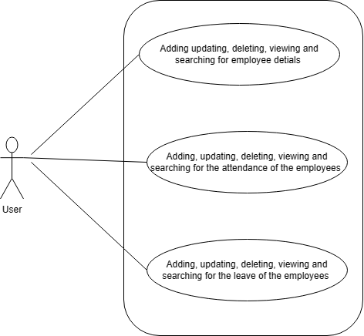

FIGURE 1: HIGH LEVEL USE CASE DIAGRAM

## Interfaces

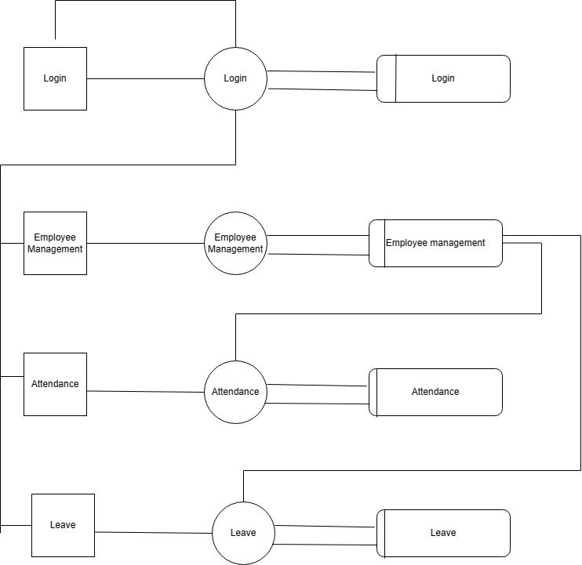

           FIGURE 2: LEVEL-1 DATA FLOW DIAGRAM

# Performance Test

Performance testing holds immense significance in any project, ensuring optimal functionality and an excellent user experience. By subjecting the system to rigorous evaluations, valuable insights are gained into its responsiveness, scalability, and efficiency. Performance testing identifies and eliminates potential bottlenecks, ensuring proper functioning of database storage, API integration, and the user interface.

## Test Cases

The following are some tests and test cases representing all the possible interactions a user could have with the application:

|  |  |  |  |
| --- | --- | --- | --- |
| **Serial No.** | **Test Scenario**  **Name** | **Test Data** | **Expected Result** |
| 1 | Nothing-I/P | No input (empty field) is entered and the “Add” button is clicked. | Error message displaying enter the details |
| 2 | Invalid-email id | When an invalid email id is entered by the user | Error message displaying invalid email id |
| 3 | Invalid-phone no | When an invalid phone number is entered by the user | Error message displaying invalid phone number |
| 4 | Invalid- employee id | When an invalid employee id is entered by the user while searching for an employee’s data | Error message displaying that an invalid Eid |
| 5 | Clicking the add button | When a user clicks on the add button after entering all the details. | A dialog box opens and displays employee added successfully |
| 6 | Clicking the update button | When a user clicks on the update button after update some values of the employes. | A dialog box opens and displays employee updated successfully |
| 7 | Clicking on the delete button | When a user selects the row that they want to delete a click on delete buttons. | A dialog box opens and displays employee deleted successfully |
| 8 | Clicking on the search button | When a user enters the employee id whose details they want to search. | It displays the details of the employee in the table based on the employee id that has been entered |
| 9 | Clicking on clear | When a user clicks the clear button | It will clear or erase all the details that the user has entered. |

## Test Procedure

* Test Objective: To verify that the HR system can perform the following functions: employee management, attendance and leave management.
* Test Scope: To cover all the features and modules of the HR system, as well as the user interface and user experience.
* Test Data: To use realistic and valid data for employees, attendance, leave.
* Test Cases: To use the following test cases for each function of the HR system:

Employee management:

Add a new employee with valid information

Update an existing employee with valid information

Delete an existing employee with valid information

View an existing employee with valid information

Search for an existing employee with valid criteria

Attendance and leave management:

Track the attendance of an existing employee with valid date and time

Manage the leave of an existing employee with valid type and duration

Set and enforce the attendance and leave policies and rules with valid parameters

View the attendance and leave records of an existing employee with valid date

Search for the attendance and leave records of an existing employee with valid

## Performance Outcome

The final results and outcomes of all the test cases listed earlier are in the below table

|  |  |  |  |
| --- | --- | --- | --- |
| **Serial No.** | **Test Scenario**  **Name** | **Actual Result** | **Final Outcome** |
| 1 | Nothing-I/P | Error message displaying enter the details | Pass |
| 2 | Invalid-email id | Error message displaying invalid email id | Pass |
| 3 | Invalid-phone no | Error message displaying invalid phone number | Pass |
| 4 | Invalid- employee id | Invalid- employee id | Pass |
| 5 | Clicking the add button | A dialog box opens and displays employee added successfully | Pass |
| 6 | Clicking the update button | A dialog box opens and displays employee updated successfully | Pass |
| 7 | Clicking on the delete button | A dialog box opens and displays employee deleted successfully | Pass |
| 8 | Clicking on the search button | It displays the details of the employee in the table based on the employee id that has been entered | Pass |
| 9 | Clicking on clear | It will clear or erase all the details of the user. | Pass |

# My learnings

Through my internship in Java and my Java project for Human Resource Management System, I have learned and improved the following:

* **Java programming skills:** I have learned how to use various Java features, such as classes, objects, methods, inheritance, polymorphism, interfaces, exceptions, collections, generics, and streams. I have also improved my coding style, syntax, and conventions.
* **Database skills:** I have learned how to use MySQL as the database for my project. I have learned how to create, modify, and query tables, as well as how to use primary keys, foreign keys, indexes, and constraints. I have also learned how to use JDBC to connect and interact with the database from my Java code.
* **User interface skills:** I have learned how to use Swing as the graphical user interface for my project. I have learned how to create and customize various components, such as frames, panels, buttons, labels, text fields, tables, and dialogs. I have also learned how to use layout managers, event listeners, and action handlers.
* **Software engineering skills:** I have learned how to apply the principles and practices of software engineering to my project. I have learned how to analyze the requirements, design the architecture, implement the functionality, test the quality, and document the code. I have also learned how to use tools such as Eclipse IDE, Git version control, and JUnit testing framework.
* **Problem-solving skills:** I have learned how to solve various problems and challenges that I encountered during my project. I have learned how to research online sources, such as Stack Overflow, Oracle documentation, and YouTube tutorials. I have also learned how to debug and fix errors and bugs in my code.
* **Communication skills:** I have learned how to communicate effectively with my mentor and peers during my internship. I have learned how to ask questions, give feedback, present my work, and collaborate on tasks.

# Future work scope

Some of the possible future work scope for my project are:

* Adding more features and modules to the HR system, such as payroll, performance management, training, and employee engagement. These features and modules would allow the HR system to cover more aspects of the employee lifecycle and provide more value to the organization and its employees. For example, payroll would automate the calculation and distribution of salaries and taxes, performance management would facilitate the setting and tracking of goals and feedback, training would enable the delivery and assessment of learning content and courses, and employee engagement would measure and improve the satisfaction and retention of employees.
* Improving the user interface and user experience of the HR system, such as using more colors, icons, animations, and tooltips. These improvements would make the HR system more attractive, intuitive, interactive, and user-friendly. For example, colors would create contrast and hierarchy, icons would convey meaning and functionality, animations would add motion and feedback, and tooltips would provide guidance and information.
* Implementing security and authentication mechanisms to the HR system, such as using encryption, hashing, salting, and tokens. These mechanisms would protect the data and privacy of the organization and its employees from unauthorized access or modification. For example, encryption would transform the data into unreadable format, hashing would generate unique identifiers for the data, salting would add random characters to the data, and tokens would verify the identity of the users.
* Integrating the HR system with other systems and tools, such as email, calendar, chatbot, or AI. This would allow the HR system to communicate and exchange data with other systems and tools that are relevant to HR processes and tasks. This would provide benefits such as automation, efficiency, accuracy, and intelligence. For example, automation would reduce manual work and human errors by performing repetitive or routine tasks automatically, efficiency would save time and resources by streamlining workflows and processes, accuracy would improve data quality and consistency by eliminating discrepancies or inconsistencies, and intelligence would enhance decision-making and problem-solving by providing insights and recommendations.